Why do you believe one word the Modern Medical Industry says? They have utterly failed in the face of heart disease and cancer. Exactly what piece of evidence has been demonstrated to you that an organism called a virus even exists? Did you know that no such organism with either a nucleus, a respiratory system, a reproductive system or a digestive system has ever been seen or isolated under a microscope? Did you know that thousands of people in America eat a raw primal diet of raw eggs, raw milk and raw meat(yes including chicken) on a daily basis and not only do not get sick from it but have seen long-term illnesses disappear in a matter of months, sometimes weeks? I know because I am one of them. From 2009 to 2019, but especially 2017-2019, I suffered extreme fatigue, shortness of breath, and chest pains. I visited the emergency room nine times from early 2017 to October 2019, with extreme fatigue, chronic shortness of breath and chest pains, only to be told everything was fine and I just needed to relieve some stress. The Modern Medical Industry took years of my life from me with their baseless and failed Germ Theory of Disease. Once Aajonus Vonderplanitz, through his students, disillusioned me of the Modern Medical Industry’s blind devotion to sterilization and taught me the essential nature and ubiquity of bacteria in all healthy tissue (pace the experiments of Antione Bechamp), not only in all biological life, but especially in the digestive processes of the body, I was now freed to enjoy my life once again. I have eaten raw eggs, raw milk, raw meat, raw butter and raw kefir on a daily basis for over 6 months with nothing but continued improvement in my health. As a result, I have no more fatigue, shortness of breath or chest pain from esophageal inflammation brought on by acid reflux. According to the Modern Medical Industry my diet should be an overload of bacteria and pathogens that should certainly have resulted in hospitalization or death. Not so much. Another result has been a complete lack of desire to drink sugary caffeinated beverages. My body is now getting the energy it needs from raw fat. Can you say the same with your Germ Theory informed diet? Not so much. Once doctors and medical journals began openly admitting that bacteria is not only ubiquitous but that what they call viruses abide in the human body asymptomatic regularly, the entire Germ Theory became nothing but Special Pleading. In protecting their investments, the U.S. Government deliberately refuses to require its schools to give people a rudimentary education which is why the reader most likely had to Google search what Special Pleading even means. This is why when you press them on Koch’s Postulates, especially Postulate 1, you get nothing but sophistry and contradictions. Moreover, Professor Barry Fox admitted in his An Introduction to Infectious Diseases that 80% of the time they have no way of determining the cause of foodborne illness.

On the contrary, what you most likely were never introduced to in School were all the men who disagreed with Louis Pasteur’s Germ Theory in the 19th century. Antoine Bechamp was Professor of Chemistry at the University of Strasbourg(1854) then after receiving his medical degree earned a position of Dean of the Faculty of Medicine at the
Universite Lile Nord de France. Germ theorists, in their childish bitterness, if they even have the grit to mention Bechamp to their audience, will often introduce him, not as the expert in chemistry and medicine that he was, but introduce him as an insect enthusiast. Bechamp’s observations led him to the conclusion that all biological life was based in a substance he called microzymas granules. These microzymas granules produce cells, bacteria, solvents/exosomes(today confused as viruses) etc. or whatever else the body needs for biological function and healing. Thus, they are Pleomorphic. Bechamp maintained that there is no immune system; that the healing process of the body is solely lymphatic or toxin dispelling. Thus, when a toxin has entered the body, if our innate bacteria are not strong enough to break it down, the microzymas will produce a solvent or exosomes to break down the toxin. This is what a flu is. Newfound cell defense system features toxin-isolating 'sponges' by NYU Langone Health / NYU School of Medicine, March 4, 2020 states,
“Exosomes act much like a sponge, preventing the toxins for a time from attacking the cell, while toxins that are not corralled are left to burrow through cell membranes," says study co-senior investigator Ken Cadwell, PhD.”

This is precisely what the Modern Medical Industry is getting wrong in our current Coronavirus “Pandemic”. I presently believe the severity of the “problem” is a planar hoax devised to collapse the world economy and fulfill the long known laissez-faire Capitalist-Social Darwinist-Globalist plan to depopulate the Earth, pace Agenda 21. However, the image of COVID-19 they are showing us is a legitimate biological entity and we should understand how to interpret the data the CDC and the Media are using to shut our country down. According to Dr. Andrew Kaufman, M.D. exosomes are induced by toxins, stress, cancer, ionizing radiation, infection, injury, immune response, asthma, diseases, and electromagnetic radiation. Thus, they are a result of illness and not the cause of illness, exactly as Bechamp stated in the 19th century. As we can see exosomes are identical in appearance to the images we have been shown of the Coronavirus (COVID-19):

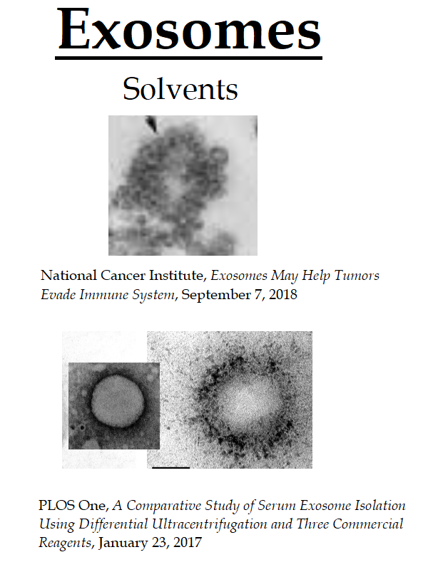
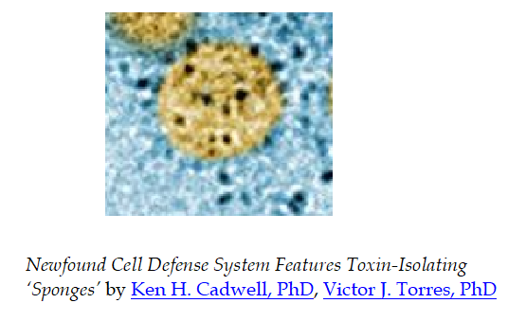

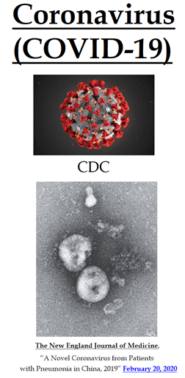

The Coronavirus (COVID-19) is a Misidentified Exosome

The Continued Failure of the Germ Theory of Disease and an Exposure of the Domestic Terrorists That Run the U.S. Healthcare Industry

southernprotestant.com

Prof. John R. Roth “[Salmonella] is mostly reported as a pathogen…but probably it exists in very many organisms at a low level where it is not a pathogen but living as part of the gut flora.” Emily Green, “The Great Egg Panic” Los Angeles Times, Jan. 5, 2000; Yale Medicine, “Salmonella Vector Overcomes an Obstacle” Yale School of Medicine (Spring 1999), https://medicine.yale.edu/news/yale-medicine-magazine/salmonella-vector-overcomes-an-obstacle/; The Hospital For Sick Children, “Scientists Use Bacterial Toxin To Kill Brain Tumors” Science Daily(July, 1999), https://www.sciencedaily.com/releases/1999/07/990701070106.htm
https://www.andrewkaufmanmd.com/

